EPRI OpenESB Mediator Services How-To-Deploy Tutorial

1023648
Final Report, January 2017

DISCLAIMER OF WARRANTIES AND LIMITATION OF LIABILITIES
THIS DOCUMENT WAS PREPARED BY THE ORGANIZATION(S) NAMED BELOW AS AN ACCOUNT OF WORK SPONSORED OR COSPONSORED BY THE ELECTRIC POWER RESEARCH INSTITUTE, INC. (EPRI). NEITHER EPRI, ANY MEMBER OF EPRI, ANY COSPONSOR, THE ORGANIZATION(S) BELOW, NOR ANY PERSON ACTING ON BEHALF OF ANY OF THEM:
(A) MAKES ANY WARRANTY OR REPRESENTATION WHATSOEVER, EXPRESS OR IMPLIED, (I) WITH RESPECT TO THE USE OF ANY INFORMATION, APPARATUS, METHOD, PROCESS, OR SIMILAR ITEM DISCLOSED IN THIS DOCUMENT, INCLUDING MERCHANTABILITY AND FITNESS FOR A PARTICULAR PURPOSE, OR (II) THAT SUCH USE DOES NOT INFRINGE ON OR INTERFERE WITH PRIVATELY OWNED RIGHTS, INCLUDING ANY PARTY'S INTELLECTUAL PROPERTY, OR (III) THAT THIS DOCUMENT IS SUITABLE TO ANY PARTICULAR USER'S CIRCUMSTANCE; OR
(B) ASSUMES RESPONSIBILITY FOR ANY DAMAGES OR OTHER LIABILITY WHATSOEVER (INCLUDING ANY CONSEQUENTIAL DAMAGES, EVEN IF EPRI OR ANY EPRI REPRESENTATIVE HAS BEEN ADVISED OF THE POSSIBILITY OF SUCH DAMAGES) RESULTING FROM YOUR SELECTION OR USE OF THIS DOCUMENT OR ANY INFORMATION, APPARATUS, METHOD, PROCESS, OR SIMILAR ITEM DISCLOSED IN THIS DOCUMENT.
The following organization(s), under contract to EPRI, prepared this report:
Boreas Group LLC

NOTE
For further information about EPRI, call the EPRI Customer Assistance Center at 800.313.3774 or
e-mail askepri@epri.com.
Electric Power Research Institute, EPRI, and TOGETHER…SHAPING THE FUTURE OF ELECTRICITY are registered service marks of the Electric Power Research Institute, Inc.
Copyright © 2017 Electric Power Research Institute, Inc. All rights reserved.
Acknowledgments
The following organization(s), under contract to the Electric Power Research Institute (EPRI), prepared this report:
Boreas Group LLC
730 S. Elizabeth St.
Denver, CO 80209
Principal Investigator
William “Bill” Boswell
Robert J. Sarfi

This report describes research sponsored by EPRI. EPRI would like to acknowledge the support of the National Energy Renewables Laboratory.

Abstract

The OpenESB Mediator Service provides a method to proxy between two vendors/services, in a more typical environment that a point to point integration. The mediator service allows dynamic configuration of vendor endpoints, clones the message for consumption by the EPRI Semantic Test Harness(reference?), and records success or failure by either vendor. Like the test harness, it provides feedback to vendors, allowing for self-diagnosis. This feedback is invaluable to vendors in ensuring CIM compliance.

The main goals of the mediator service are to:

- Lower costs of adopting the CIM by making information easily available in a self-service application to validate and generate messages providing vendor feedback and self-diagnosis;
- Provide a future framework for additional certification; and
- Provide an extensible framework for additional web service/standards.

The mediator service is designed to work in a cloud environment, with support for multiple vendors in a single instance. Of course, the application can also be deployed in any Windows or Unix based environment. In addition to the actual web services, the mediator service also contains a web based user interface, for configuration and reporting.

The remainder of this document describes how EPRI personnel can create and deploy the mediator service to additional instances.

Keywords
Common Information Model (CIM), interoperability, Enterprise Service Bus (ESB), web services

Contents
1 INTRODUCTION 1
2 Getting Started 2
3 Deploying applications to a Server instance 3
4 Configuring the Database 10
5 testing the application 13
6 Glossary 18

List of Figures
Figure 1: ESB Console, showing Shared Libraries menu option 6
Figure 2: ESB Console, showing Shared Libraries installation dialog 7
Figure 3: ESB Console, showing Components dialog 8
Figure 4: ESB Console, showing sun-http-binding component 9
Figure 5: ESB Console, showing application variables 9
Figure 6: Message flow diagram for mediator service 10
Figure 7: Message Header example 12
Figure 8: Vendor Test Sequence Dialog 13
Figure 9: Vendor Test Sequence and Steps dialog 13
Figure 10: SoapUI menu for GetDERGroupStatuses 14
Figure 11: SoapUI how to modify destination endpoint 15
Figure 12: Mediator UI, modifying the “to” Vendor endpoint 16
Figure 13: SoapUI, successful response received 16

INTRODUCTION

The EPRI OpenESB Mediator Service provides a novel platform through which vendors may easily evaluate communication interoperability between systems. The mediator service consists of a set of web service interfaces and corresponding database for tracking/reporting. The mediator services is designed to run on a cloud environment. Multiple vendors can share a single environment. There are several steps required to create a new instance, but each step is straightforward.

The instructions below are for a typical Linux environment. The mediator service has also been tested under Windows 7.

Getting Started

We assume that you have an available server, of some Linux flavor. These instructions are for Centos, but can easily be adapted to other Linux variations. This document assumes that the installer has familiarity with Linux, MySQL, soapUI(for testing), and web services in general.

Deploying applications to a Server instance

There are several applications that must be deployed, this section will list each in turn.

Deploying MySQL

Log into the test instance. You will need the following files from the repo:

Latest database dump: interop_dev_01152017.mysql

Installing mysql56 using yum:

sudo yum install mysql56.x86_64
sudo yum install mysql56-server.x86_64
sudo yum install mysql56-devel.x86_64

Make sure mysql is set to autostart on server reboot (this may be done automatically by some installers).
Start the mysqld service, if it’s not already started.

sudo service mysqld start

Use the mysql client to connect to the instance.

mysql –u root

Create a database
mysql> create database interop_dev;

Create a new user and grant permissions
mysql> create user 'interop_dev’@'localhost' identified by 'interop_dev';
mysql> grant all on interop_dev.* to ‘interop_dev’@’localhost’;

Change to new user
mysql> exit;

Import the default schema
mysql -u interop_dev -p interop_dev < interop_dev_01152017.mysql

Installing tomcat

On Centos, tomcat is easily installed using yum. It can also be downloaded as a tarball and installed that way.

Installing via yum:
sudo yum install tomcat7-noarch tomcat7-admin-webapps.noarch tomcat7-el-2.2-api.noarch tomcat7-jsp-2.2-api.noarch tomcat7-lib.noarch tomcat7-log4j.noarch tomcat7-servlet-3.0-api.noarch tomcat7-webapps.noarch

The yum installer places it in /usr/share/tomcat7. We will assume this directory for future instructions.

Set it up to auto start on reboot, if the script did not do it for you.

Make sure it is started:
service tomcat7 start

Deploy the test harness war file

You will need the following file from the repository:

epriConnect.war

Simply copy the epriConnect.war file into the /usr/share/tomcat7/webapps directory, then restart tomcat.
sudo service tomcat7 stop
sudo service tomcat7 start

Install ruby on rails and UI application

You will need to following files from the repo: ???
i2.tgz

This script assumes a local user account named testui. Login using the testui account

First, install RVM, to pull the specific version of ruby
gpg2 --keyserver hkp://keys.gnupg.net --recv-keys 409B6B1796C275462A1703113804BB82D39DC0E3
mkdir rvm; cd rvm
curl -sSL https://get.rvm.io | bash -s stable
source /home/testui/.rvm/scripts/rvm
rvm install 2.2.3

Confirm that you have the correct version by issuing:

ruby –version

Next, install the UI application

sudo mkdir /usr/local/mediatorui
sudo chown /usr/local/mediatorui
cd /usr/local/mediatorui
tar xvzf pathto/i2.tgz

gem install rails
gem install mysql
bundle update

Now start the application, default port is 3000

nohup rails s –b 0.0.0.0

You may verify that the application is up by using a browser to access:

http://yourserver:3000

Installing OpenESB

You will need the following files from the repo:
openesb3.0.5.zip
mysql-connector-java-5.1.38-bin.jar
context.xml

Unzip the openesb zip file into /usr/local
cd /usr/local
unzip openesb3.0.5.zip

Create a symbolic link for convenience:

ln –s OpenESB-SE-3.0.5 openesb

Copy the mysql connector into the OpenESB directory
cp pathto:/mysql-connector-java-5.1.38-bin.jar /usr/local/openesb/OE-Instance/lib/ext

Copy the context.xml file into the OpenESB directory
cp context.xml /usr/local/openesb/OE-Instance/config

Now, start the server
/usr/local/openesb/OE-Instance/bin/openesb.sh

Verify that the server is up by connecting to it via the admin console, via a browser

Use url http://yourserver:4848/plugin/webui

Login using the default credentials, admin/admin

Install required files

Now that you have a working server, several components must be installed. These files are already part of the openesb install, but must be configured. For convenience, unzip the openesb zip file to the machine that you are browsing from – this will make it simpler to select files when instructed to do so.

Load shared libraries:

- Access web console : http://yourserver:4848/plugin/webui
- Click on Shared Libraries (on left menu)

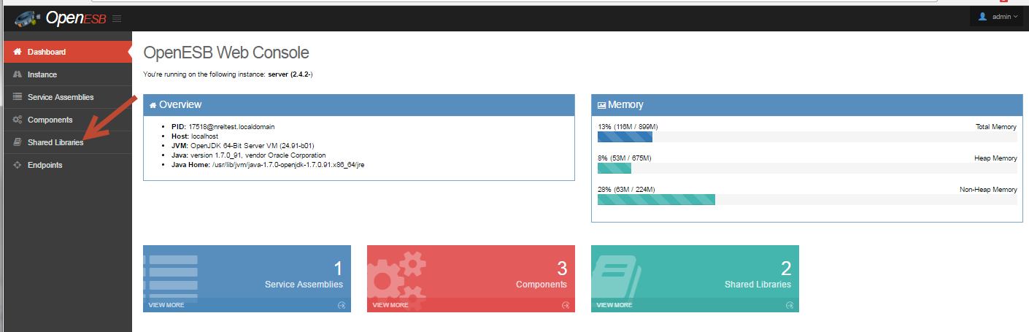

Figure 1: ESB Console, showing Shared Libraries menu option

- Click Install
- Select file : /usr/local/OpenESB-SE-3.0.5/OE-Components/encoderlib.jar
- Click ‘Start upload’

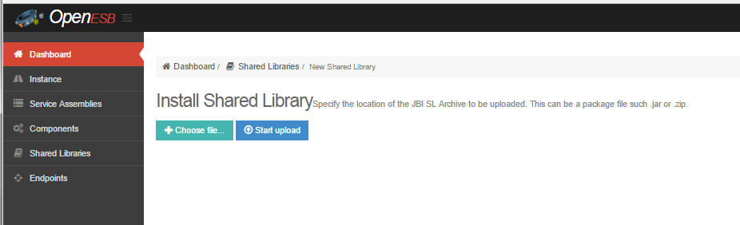

Figure 2: ESB Console, showing Shared Libraries installation dialog

- Repeat process for wsdlextlib.jar

Install the three required components

- Access web console : http://localhost:4848/plugin/webui
- Click on Components (on left menu)
- Click Install
- Click ‘Choose File’
- Select file : /usr/local/OpenESB-SE-3.0.5/OE-Components/bpelse.jar
- Click Install

- Repeat process for filebc.jar and httpbcfull.jar

The instance is now configured. Additional settings must be modified after mediator applications are installed.

Installing the Mediator Applications

You will need the following files from the repo:

ExecuteDERGroupDispatchesApp.zip
GetDERGroupStatusesApp.zip

- Access web console : http://localhost:4848/plugin/webui
- Click ‘Service Assemblies’ (left side menu)
- Click on ‘+ Deploy’ button
- Choose file : GetDERGroupStatusesApp.zip
- Click ‘Start upload’
- Click ‘Start’ button on the service assembly page

Note: the start will partially fail at this point, but it will also create the endpoint variables (initially set to null) for the next step.

- Repeat for ExecuteDERGroupDispatchesApp.zip

Endpoint Configuration

The mediator endpoint are configurable. There are three endpoints for each mediator application. One for ESB endpoint, one for the remote server, and one for the test harness.

GetDERGroupStatuses variables:

- status_remote_server
- status_log_server
- status_esb_server

ExecuteDERGroupDispatches variables:

- dispatch_remote_server
- dispatch_log_server
- dispatch_esb_server

To access and set the variables:

- Access web console : http://localhost:4848/plugin/webui
- Click on Components (left menu)
- Click on sun-http-binding item

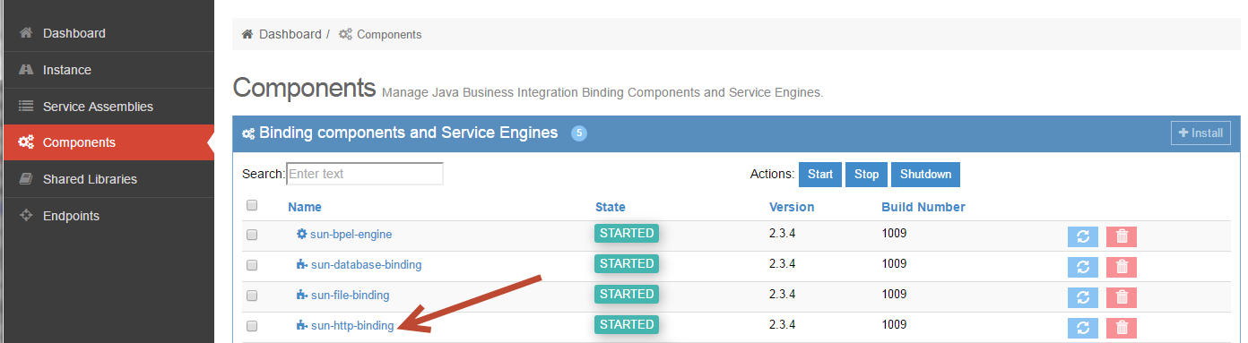

Figure 3: ESB Console, showing Components dialog

- Click on ‘Application Variables’
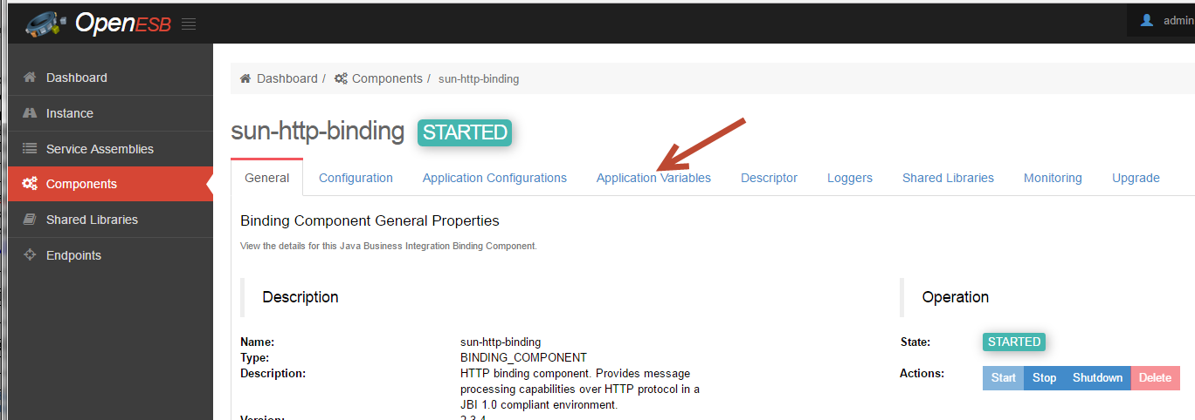

Figure 4: ESB Console, showing sun-http-binding component

Each variable already has a default value. For our setup, they should be defined as follows:

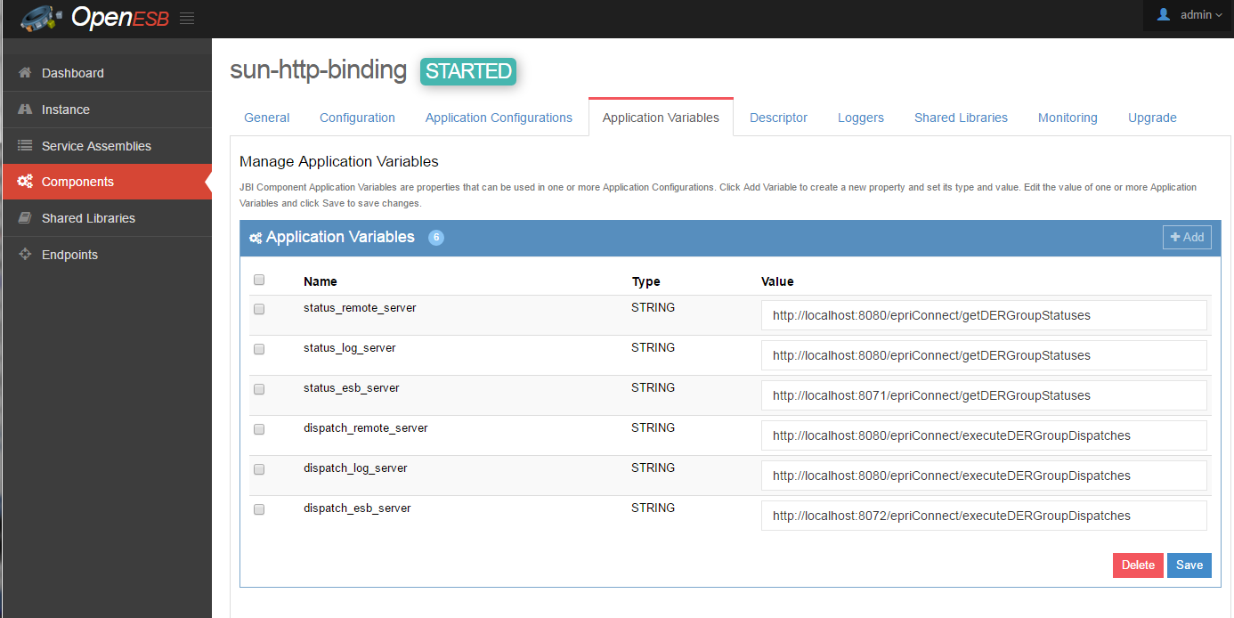
Figure 5: ESB Console, showing application variables

Note that XXXXX_remote_server variables are identical to the XXXXX_log_server variables. This is because these variables are overwritten based on the database configuration, which is explained later.

After making all the changes, stop and restart the openESB server. You may need to clear browser cache settings in order for the updated values to display correctly.

Configuring the Database

The mediator applications come with a user interface, to allow vendor to vendor test setup. A users guide is available in a separate document.

The mediator services use database values to determine where to forward messages. The flow diagram is show below. Note the application variable names(defined in the ESB admin console) referenced in the diagram.

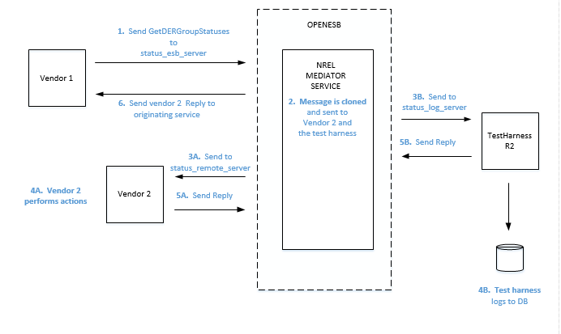

Figure 6: Message flow diagram for mediator service

The status_remote_server variable, actually all the XXXX_remote_server variables, as seen in figure 5, are overridden by values configured in the database. This allows for multiple vendor to vendor test pairs to be defined for the same message

Database concepts

A brief note on the database structures.

vendor
Represents a vendor – there can be multiple users associated with a vendor.
test_sequence
A predefined generic test sequence, consisting of one or more message flows
test_sequence_steps
This table defines the message flows for a specific test_sequence
vendor_test_sequence
A vendor specific message sequence – A test_sequence was selected for a vendor pair and configured
vendor_test_sequence_steps
Matching entries for test_sequence_steps, overriding the delivery URL(XXX_remote_server) for the specified message

Since each vendor may want to test the same sequence with multiple vendors, a user name is associated with each vendor_test_sequence. A message header convention is used to identify the vendor and associated user.

Message header example
In the example message below, note the circled fields in the message header. The Organization field specifies the vendor, while the UserId field species the user.

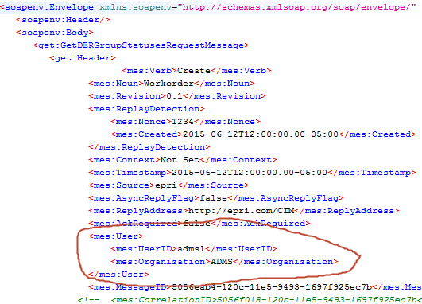

Figure 7: Message Header example

There are predefined vendor test sequences in place for ExecuteDERGroupDispatches and GetDERGoupStatuses.

To view them, and to change the paired vendor URL(the URL that the mediator applications will forward the message to), access the ESB mediator UI at http://yourserver:3000

After logging into the UI, and accepting the EPRI terms of service, you are presented with the dashboard view. Click on Vendor Test option in the top level menu bar.

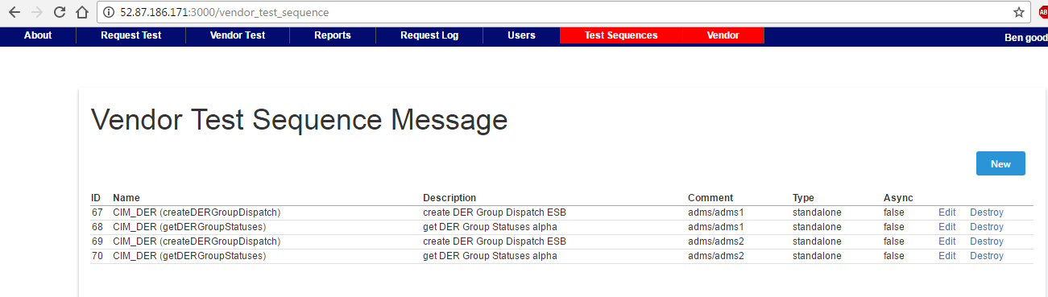
Figure 8: Vendor Test Sequence Dialog

In this display, we see that there are 4 vendor test sequences defined. GetDERGroupStatuses, vendor ADMS, for two users – adms1 and adms2. Similarly, ExecuteDERGoupDispatches is also defined for vendor ADMS, for users adms1 and adms2

Clicking on “Edit” for the first item in the list brings us the details of the vendor_test_sequence, see the figure below. Note in the following dialog that you can specify the user id, as well as edit the actual vendor_test_sequence_step record. The red arrow points to the field that is used to specify the XXX_remote_server value, overriding the value that was specified in the application variables dialog, in Figure 5.

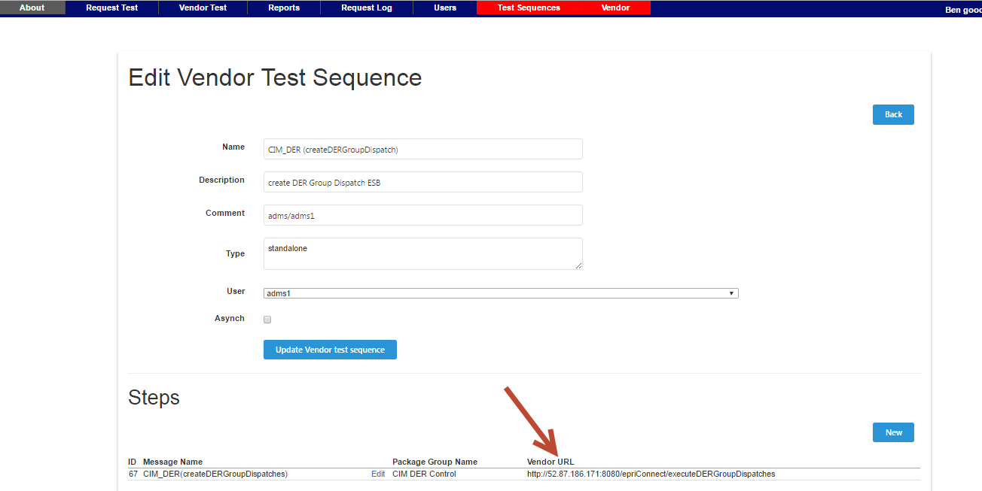

Figure 9: Vendor Test Sequence and Steps dialog

testing the application

We will test the mediator application using soapUI. We will use soapUI to send in a GetDERGroupStatuses message using the test harness as the second vendor.

You will need the following file from the repo:
soapui/GetDERGroupStatuses-soapui-project.xml

- Start soapUI
- Go to File/Import Project, and select the file soapui/GetDERGRoupStatuses-soapui-project.xml
- Expand the tree as shown in the figure below, then double click on the GetDERGroupStatuses item

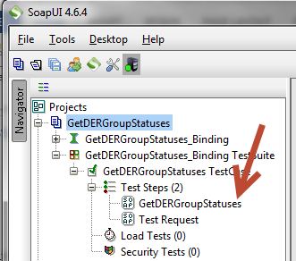

Figure 10: SoapUI menu for GetDERGroupStatuses

After double-clicking on the item, the test message will popup in a window in the work area.

We need to do the following:
Change the soapUI destination endpoint to point the the openESB endpoint
Modify the forwarding endpoint in the database to point to the test harness

Changing the soapUI destination endpoint

The correct endpoint URL can be found in Figure 5, in the status_esb_server variable. Set this value as the endpointof the soapUI message, as shown in the figure below.

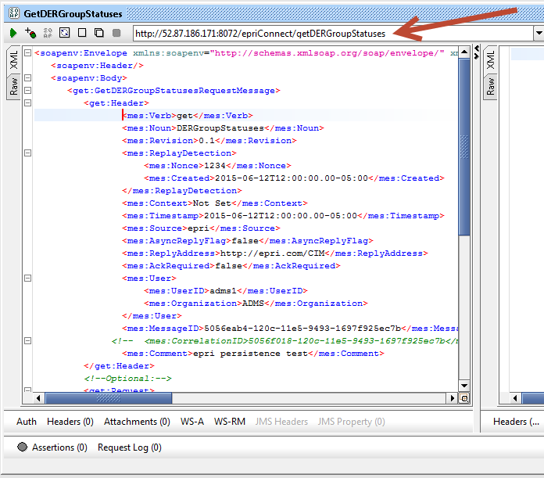

Figure 11: SoapUI how to modify destination endpoint

Modify the forwarding endpoint

Now modify the database configuration to point to the test harness, as if it was vendor 2. In the Mediator Configuration UI, click on Vendor Test, then click the Edit button for the getDERGroupStatuses item, where the comment is adms/adms1(Note that this matches the header value in the message).

On the detail page, click the Edit button in the single test step, to bring up the dialog shown below.

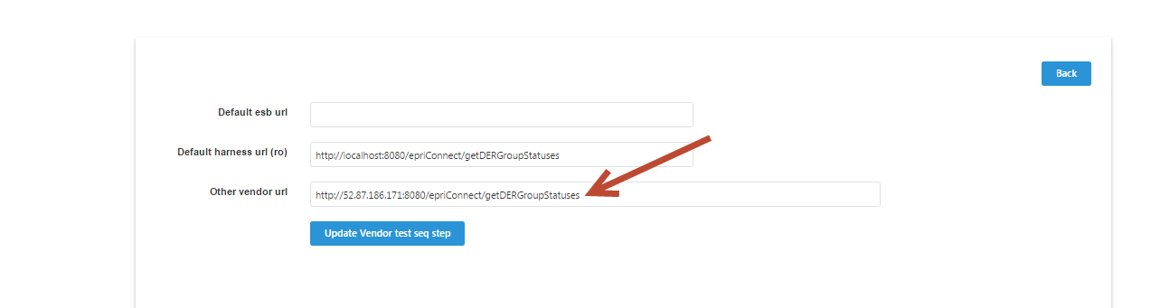

Figure 12: Mediator UI, modifying the “to” Vendor endpoint

In this dialog, edit the Other Vendor URL using the value show above, but substituting your server name/ip for the given IP address(52.87.171.186). Using localhost should also work correctly.

Use soapUI to send the message(click the green arrow in the menu bar).
You should get a default response from the test harness, as shown in the figure below.

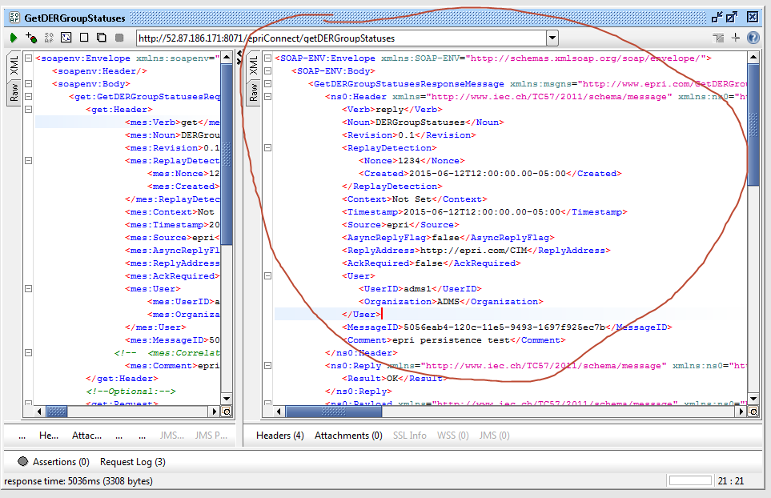

Figure 13: SoapUI, successful response received

That’s it! You have successfully sent a message through the ESB to a receiving endpoint.

Glossary
AMI Automatic Metering Infrastructure
CIM Common Information Model
CIS Customer Information System
COTS Commercial off the shelf software
DMS Distribution Management System
DNS Domain Name Service
ESB Enterprise Service Bus
MDMS Meter Data Management

UI User Interface

